Clinical Treatment Guideline for NightWare
July 2023

Patient Selection
- Sympathetic nervous system activation is necessary to detect nightmares. Patients should have one or more of the following symptoms:
  - Sweating
  - Palpitations, pounding heart, or accelerated heart rate
  - Trembling or shaking
  - Sensations of shortness of breath or smothering
  - Feeling dizzy, unsteady, lightheaded, or faint
  - Feeling of choking
  - Chest pain or discomfort
  - Nausea or abdominal distress
  - Numbness or tingling sensations
  - Fear of losing control
  - Derealization (feelings of unreality)
  - Chills or hot flashes
  - Depersonalization (being detached from oneself)
  - Fear of dying
- NightWare reduces sleep disturbances related to sympathetic activation.
- Good candidates for NightWare include patients who have not responded to other treatments, are motivated to use the device, have no interfering medical conditions, have difficulty adhering to traditional treatments, or are motivated to use technology.
- Alcohol use, sleep anxiety, and menstrual cycle impacts should be considered and addressed to optimize treatment outcomes with NightWare.

Because NightWare relies on increases in heart rate and movement to detect nightmares, we recommend prescribing NightWare to patients that have symptoms of sympathetic activation when they have nightmares. These symptoms include sweating, waking in a panicked state, palpitations, and gasping for air.
NightWare may be especially useful for patients who are not good candidates for medication due to concerns about side effects or who have had limited success with other treatments like CBT. NightWare can help regardless of trauma. Patients with combat trauma, sexual trauma, and childhood trauma can all benefit from NightWare. Patients who may not have easy access to specialized care could benefit from NightWare. This could include patients who live in rural or remote areas, patients who have limited mobility or transportation, or patients who work unconventional hours that make it difficult to attend appointments.
Patients who are motivated to use technology and are willing to engage with the device as part of their treatment plan could be good candidates for NightWare. This may include younger patients or patients who are comfortable using technology as part of their daily lives.

It was also noted that alcohol use can be a significant contributor to poor outcomes with NightWare. Clear communication between clinician and patient is essential for optimizing outcomes regarding alcohol and NightWare. Further, clinicians should do their best to coach patients to help them avoid sleep anxiety. It can also be important to educate patients on the impacts that menstrual cycles can have on nightmares.

It is important to note that while NightWare may be beneficial for some patients, it is not appropriate for everyone. Clinicians should carefully consider the individual needs and preferences of each patient before recommending NightWare as a treatment option. Additionally, clinicians should ensure that patients are fully informed about the device, its potential benefits and limitations, and the level of engagement required to use it effectively.
Customization of the device is critical to ensure its effectiveness and patient satisfaction. Several factors should be considered when customizing the device, including the patient's sleep habits, bedtime routine, and the severity of nightmares. The device should be calibrated to detect the patient’s unique movements during nightmares and should be set to an appropriate threshold for intervention. Patients should be educated on the importance of using the device consistently and encouraged to adjust settings as needed to achieve optimal results. Some patients may benefit from using the device in combination with other relaxation techniques or medications.

NightWare will reduce sleep disturbances and help improve the quality of sleep for patients with nightmares, but the quantity and regularity of sleep are also important for optimum daytime functioning. The important points to counsel the patients are the basics of good sleep hygiene, allowing time for calm activities for an hour prior to sleep, avoiding lying awake in bed for long periods of time, and maintaining a regular sleep schedule.

Clinical Assessment Tools

Before starting NightWare treatment
- Use appropriate metrics to establish a patient baseline for nightmares and sleep disturbances with the PSQI-A or NDI
- Question two on the PCL-5 can be useful for assessing nightmare frequency and severity in PTSD patients.
- The PCL-5 is a widely used tool in clinical practice for patients with PTSD and can be incorporated into standard procedures.

Providers may use one of many questionnaires to establish the baseline severity of nightmares The Nightmare Disorder Index (NDI) or the Pittsburgh Sleep Quality Index Addendum (PSQI-A) to establish the baseline scores for reference. Question 2 of the PCL-5 can be helpful in assessing nightmare frequency and severity in PTSD patients, and the PCL-5 is widely used in Behavioral Health. The NDI is a relatively new 5-question survey that can be scored to assess the progression of nightmare disorder at baseline and post-treatment.
The PSQI-A is a self-report instrument designed to assess the frequency of seven disruptive nocturnal behaviors. Please refer to the Appendix for a copy of these questionnaires.

After using NightWare treatment
- Repeat the PSQI-A or NDI at the 4 week follow-up appointment
At least four weeks after the start of use, providers may have follow-up with the patients and repeat the administration of the NDI or PSQI-A during follow-ups. We suggest only using the first four questions of the NDI at follow-up, as the fifth question is about the duration of nightmares and will not change with treatment. Treatment efficacy and safety may be assessed by comparing the scores obtained at post-treatment points to the baseline.
When the patient leaves the military and moves to a civilian network provider, it is essential to transfer access to their data to their new provider. The device's data and patient information must be accurately shared with the new provider to ensure that the patient receives appropriate and continued care.

2.3 Stigma and Misconceptions

- Clinicians must address the stigma surrounding PTSD treatment and reassure patients that seeking help and using NightWare will not adversely affect their military career.
- Efforts to educate patients and the public about PTSD are important to reduce stigma and misconceptions.

There is a lingering stigma associated with behavioral health and PTSD in the military community. It was noted that many patients are reluctant to seek treatment for fear of losing their military career, clearance, or the stigma associated with PTSD. Untreated PTSD can lead to more problems with work performance and security clearances; having a PTSD diagnosis does not, in itself, endanger military careers. Clinicians need to reassure patients that seeking behavioral health care and using NightWare will not adversely affect their military career.

Instructions to Patients when Prescribing NightWare
We suggest that clinicians instruct the patient on the following points when prescribing NightWare
- NightWare will likely not intervene in sleep for the first 1-3 nights of use. This is a normal part of the software calibration process to individualize the treatment for you. Continue to use it even if you experience nightmares in these first few nights.
- For the first 30 minutes of use, NightWare will not vibrate. This is to allow you to fall asleep. Start the NightWare app on the watch when you believe you are ready to sleep. If NightWare vibrates and you have not fallen asleep yet, at least 30 minutes have passed while you were awake in bed. The best sleep practice is to turn off the NightWare app on the watch, get out of bed, and do a sleep-inducing activity until you feel that you can fall asleep. Then go to bed and start the NightWare app again.
- If there are changes to some medications, especially stimulant medications for ADHD, NightWare will need 1-3 days to adjust to the new baseline heart rate.
- Skipping a day of a stimulant medication may result in NightWare not intervening in sleep that night due to a decrease in the baseline heart rate.
- Leave NightWare running if you wake briefly during the night and intend to return to sleep (i.e., to use the restroom). The NightWare watch will likely vibrate when this occurs, but you may disregard these vibrations.
- If you are awake for an extended period of time in the middle of the night (more than 15 minutes), stop the NightWare session and then restart it when you are ready to go back to sleep. When you stop and then start a new session, there will be a 30 minute non-intervention period again. You may start and stop NightWare sessions as often as needed during the night.
- NightWare will continue to operate normally if not connected to Wi-Fi, even for prolonged periods of time. Connecting the NightWare phone to Wi-Fi will allow your health care provider to see data collected during use of the device to assist with your healthcare management.
- The NightWare data will not be collected if the NightWare iPhone does not remain charged. You cannot “over-charge” the iPhone. We highly recommend that you leave the NightWare iPhone on your nightstand with the charging and plugged in at all times.
- NightWare may be used if you have an irregular sleep cycle or shift work. Simply use NightWare every time you intend to sleep, as nightmares can happen during naps.
- NightWare will reduce sleep disturbances and help improve sleep in users, which will allow them to focus on other mental health and sleep-related problems that they may have. Other treatments, such as Prolonged Exposure Therapy, should continue while using NightWare.
- Contact your provider if daytime sleepiness occurs, or if nightmares persist or worsen.

NightWare Adherence to Treatment
NightWare, like all treatments, works best when there is consistent use. Based on published data, the current working definition of treatment adherence for NightWare is use more then 50% of nights. We recommend that clinicians emphasize this during consultations to ensure the best therapeutic outcomes, while concurrently managing comorbidities and adjusting medications as needed.

Recommendations for Follow-up for NightWare Users
- 24-72 hour follow-up by the DME provider is recommended to ensure the device is connected to Wi-Fi
- Follow-up 4 weeks starting NightWare and after changes to certain medications or with certain new diagnoses is recommended.
- Routine follow-up recommended every 12 months or as needed.
Follow-up after initiation of NightWare treatment is recommended within 24-72 hours of the start of use. This follow-up will typically be done by the DME provider for the patient.
We recommend follow-up 4 weeks after the start of use. If there are changes to medications, especially stimulant medications, or new diagnoses (i.e., sleep apnea, new arrhythmias) that may affect NightWare function, follow up 4 weeks after these changes is recommended.
If the patient is using NightWare regularly and no changes to the treatment are needed, the patient should follow-up about NightWare use every 6-12 months.
We recommend that the following be addressed at follow-up appointments:
- Changes in sleep quality, including assessing whether or not NightWare is disturbing sleep
- The change in the frequency and/or severity of nightmares
- Assess for the appearance of or change in dream-enacting behaviors and parasomnias (sleep-walking, sleep-talking, etc.)
- Assess for improvements in daytime function, including the ability to participate in therapy for mental health conditions.
- Use clinical assessment tools (section 3) to assess efficacy and safety post-treatment

Adjustment of the Intervention Threshold
- The intervention threshold is determined continuously and will fluctuate slightly in most patients.
- Over- and under-intervention can be addressed by manually adjusting the intervention threshold
- NightWare's adjustable settings allow for catering to individual patient needs; adjusting these settings is done best through an iterative approach.
- Clinicians are urged to consider patient feedback and sleep data for optimal device calibration, potentially adjusting stress thresholds and vibration intervals.
The NightWare software is designed to automatically adjust the intervention threshold to the patient’s baseline stress index. The baseline stress index is determined using the previous 1,000 minutes of use, and the intervention threshold is set at the 80th percentile of this baseline. As the baseline stress index changes, the intervention threshold will adjust up or down.
At least after 1 week of receiving treatment, if a patient complains that the device is over-intervening or under-intervening, the provider may manually adjust the intervention threshold to decrease or increase interventions.
The adjustability of NightWare’s settings based on individual patients' needs is a key point. Given the highly individualized nature of sleep and its associated disorders, a one-size-fits-all approach is not optimal. Hence, NightWare provides a calculated and personalized treatment for each user. For patients that need the treatment to be adjusted beyond the automatic adjustments the software makes, a certain degree of trial-and-error is necessary to change and optimize the device to the individual's unique needs. Clinicians should adopt an iterative approach to setting adjustments, taking into account the patient's feedback and sleep data from NightWare. These adjustments could include altering the stress threshold manually or modifying the interval in which the watch vibrates during an intervention.

Overactive Treatment
A patient’s treatment is considered to be over-intervening if:
- The patient is woken up by too much vibration more than one time per night for more than one night within three consecutive days, by self report.
- The vibration wakes up a patient more than three times in a single night, by self report.
- In the event that a device is overactive, access the participants graph on the NightWare site by selecting the patient or searching by Participant ID.
- In the “Stress” graph, review the data for the past 3 nights. Record the 2 lowest thresholds that triggered interventions by the device.
- Choose the “Settings” tab and navigate to the “Device” tab
- Set the threshold to the nearest value above the two lowest thresholds that were recorded. For example: if the two lowest thresholds are at 41 and 44, set the new threshold to 45. Use the drop-down menu under “Threshold” in the middle of the “Device” page to select the intervention threshold. (Note: the thresholds in the drop-down menu are in 5-unit increments. You can change a patient’s threshold back to “Auto” with this same menu).
- Click “Save”, document the new threshold and inform NightWare staff.

Underactive Treatment
A patient’s treatment is considered to be underactive if:
- The patient is not noticing a response to a nightmare at least two times over the course of 3 consecutive nights, by self report.
- The patient is woken up by nightmares, not by vibrations, at least two times over the course of 3 consecutive nights, by self report.
- In the event that a device is underactive, access the participants graph on the NightWare site by selecting the patient or searching by Participant ID.
- In the “Stress” graph, review the data for the past 3 nights. Record the 2 highest thresholds that triggered interventions by the device.
- Choose the “Settings” tab and navigate to the “Device” tab
- Set the threshold to the nearest value below the two highest thresholds that were recorded. For example: if the two highest thresholds are at 41 and 44, set the new threshold to 40. Use the drop-down menu under “Threshold” in the middle of the “Device” page to select the intervention threshold. (Note: the thresholds in the drop-down menu are in 5-unit increments. You can change a patient’s threshold back to “Auto” with this same menu)
- Click “Save”, document the new threshold and inform NightWare staff.

Effect of Medications on NightWare
- NightWare relies heavily on heart rate increases to determine when to intervene. Medications that affect changes in heart rate, such as beta-blockers, may interfere with NightWare’s performance.
- Starting and stopping stimulant medications will affect NightWare’s function for 1-3 nights as the software adjusts to the new baseline heart rate.
- Medications to treat sleep-related movement disorders are unlikely to affect NightWare’s function.
- Beta-blockers may decrease the effectiveness of NightWare
- NightWare Inc. has data (published in poster/abstract form) that suggests prazosin doses of 1-8 mg do not interfere with the function of NightWare.
Stimulant medications, like modafinil and amphetamine-related drugs, can cause a slight increase in the baseline heart rate during sleep, even if they are taken several hours earlier. When starting or stopping these medications for a NightWare user, it is important to remind them that it may take 1-3 nights for NightWare to adjust to the new baseline heart rate.
Beta-blockers can blunt increases in the heart rate and may result in decreased effectiveness of NightWare. This effect has not been demonstrated, however, and remains a potential interaction. Patients on beta-blockers were excluded from NightWare research, and there is no data on the effectiveness of NightWare with the concurrent use of these medications.
There is limited data that suggests that prazosin at doses of 1-8 mg nightly does not affect NightWare’s function. A case series published as a poster/abstract of Clinical Global Impression of Change (CGIC) scores in 6 clinical patients using prazosin at these doses demonstrated that these patients had clinical improvement in their sleep quality and nightmares when NightWare was added to their treatment plan. One clinician has reported NightWare working well with a patient on 15 mg of prazosin nightly. Additionally, some clinicians have had success in lowering prazosin doses after starting NightWare, and this appears to be a common approach. When a patient’s nightmares are not controlled with prazosin, NightWare is added, and then the prazosin is slowly decreased and then discontinued.
Medications which affect movement, such as treatments for Restless Leg Syndrome, can decrease movement. The effect on NightWare’s function of changes in these medications is unlikely to be significant for most patients because NightWare relies more heavily on heart rate changes than movement.

Effect of Medical Conditions on NightWare

Obstructive Sleep Apnea (OSA)
- Untreated OSA will trigger NightWare interventions. Treatment of OSA is recommended. CPAP and other OSA treatments can be used concurrently with NightWare.
Untreated Obstructive Sleep Apnea (OSA) can cause sympathetic nervous system activation and movement in patients. The increase in heart rate and movement can trigger a NightWare intervention. While not harmful to the patient, these interventions will not help either. If a patient with nightmares has risk factors for OSA, it is recommended that they be evaluated for OSA and treated.
If the patient is sleeping with OSA treatment intermittently, a pattern of frequent and infrequent interventions from NightWare is likely to result. Arrhythmias
Some arrhythmias can cause wide swings in the heart rate and can lead to triggering unnecessary interventions if there are brief periods of tachycardia unrelated to nightmares.

Insomnia
Insomnia, especially prolonged periods of wakefulness, can interfere with the function of NightWare if it is used while the patient is awake. This is because the patient’s heart rate is higher when awake than when asleep, and the device relies on machine learning to determine the patient’s heart rate during sleep.
8.3 Sleep-related Movement Disorders
Sleep-related movement disorders such as Willis-Ekbom Disease/Restless Leg Syndrome and Periodic Limb Movement Disorder has the potential to affect the function of NightWare by causing increased movements of the arms (which can happen with this condition). However, NightWare will automatically adjust to changes in movement levels during sleep, and this excessive movement is unlikely to affect NightWare’s function.
8.4 Dehydration/Hypovolemia
This can cause a slight increase in the heart rate, which may lead to more NightWare interventions in affected users.

8.5 Arrhythmias
Some arrhythmias can cause wide swings in the heart rate and can lead to triggering unnecessary interventions if there are brief periods of tachycardia unrelated to nightmares.

Artifacts
- A loose watchband has a particular appearance on the NightWare data report.
- Awakening and using the restroom during a session will cause a large spike in the heart rate and a vibration will trigger. This can be safely disregarded.
- Artifact data from sources like device malfunction or misuse are crucial to identify.
- Cross-verification of NightWare data with clinical symptoms and patient feedback is an effective way to identify artifacts and understand the patient’s sleep.

Artifacts could arise from various sources such as device malfunction, improper use including the wristband being worn too tight or loose, or external factors such as movements unrelated to sleep. Distinguishing genuine data from potential anomalies is of paramount importance, as the accuracy of NightWare data interpretation directly impacts the effectiveness of clinical decisions based on that data. Cross-verification with clinical symptoms and patient feedback is a robust method of identifying artifacts. The combination of objective data from NightWare and subjective inputs from the patient can help clinicians to form a comprehensive, reliable understanding of the patient's sleep patterns and disturbances.
NightWare’s function requires secure contact with the patient’s skin. If the watchband is too loose, the heart rate cannot be determined and NightWare will stop after 10 minutes of this lack of signal. On the stress index graph, this phenomenon will appear as a 10 minute period of a flat line at the end of a session. An example of this is seen in the screenshot below (Figure 8a).
Figure 8a
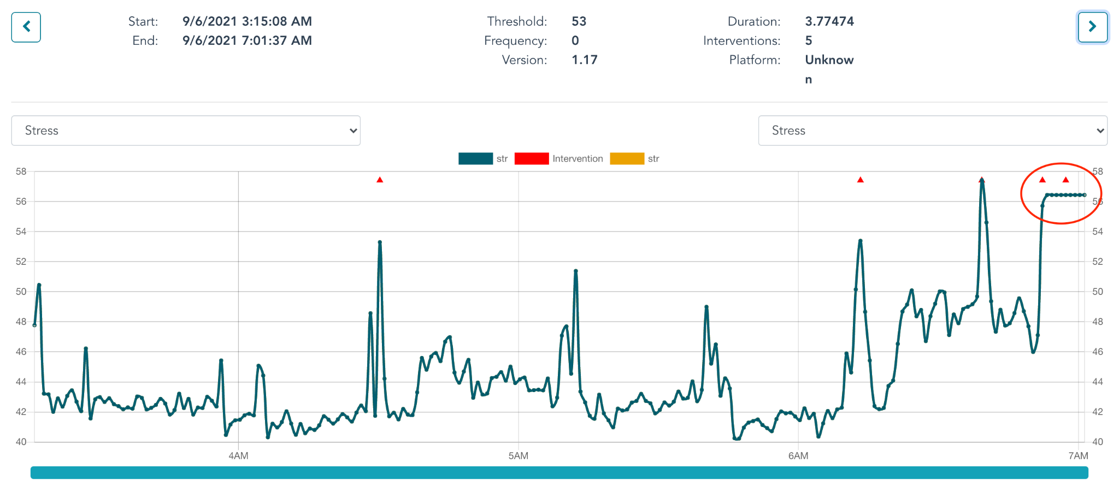
Movement during the night and at the end of a session. We recommend leaving NightWare on and running if they wake to use the restroom during the night. A large spike in the stress index can be seen with these events, and they are almost always much larger than other spikes seen during the night. These events can also occur when the patient wakes for the day but forgets to turn off NightWare. An example of this effect is seen in the screenshot below (Figure 8b).

- Patterns seen in NightWare data
With experience, distinct patterns in the collected NightWare data have been identified. Recognizing these patterns will enable the clinician to design and implement more precise, effective treatment plans and optimize the use of NightWare in patient care.
  - Insomnia, sleep-onset and sleep-maintenance types
    - Extended periods of movement and position change, coupled with an increased heart rate, indicate that the patient is awake.
  - Obstructive Sleep Apnea
    - Period of increased heart rate can indicate sleep apnea events are occurring during sleep. The amount of movement is expected to be much less than when patients are awake with insomnia.
Figure 8b
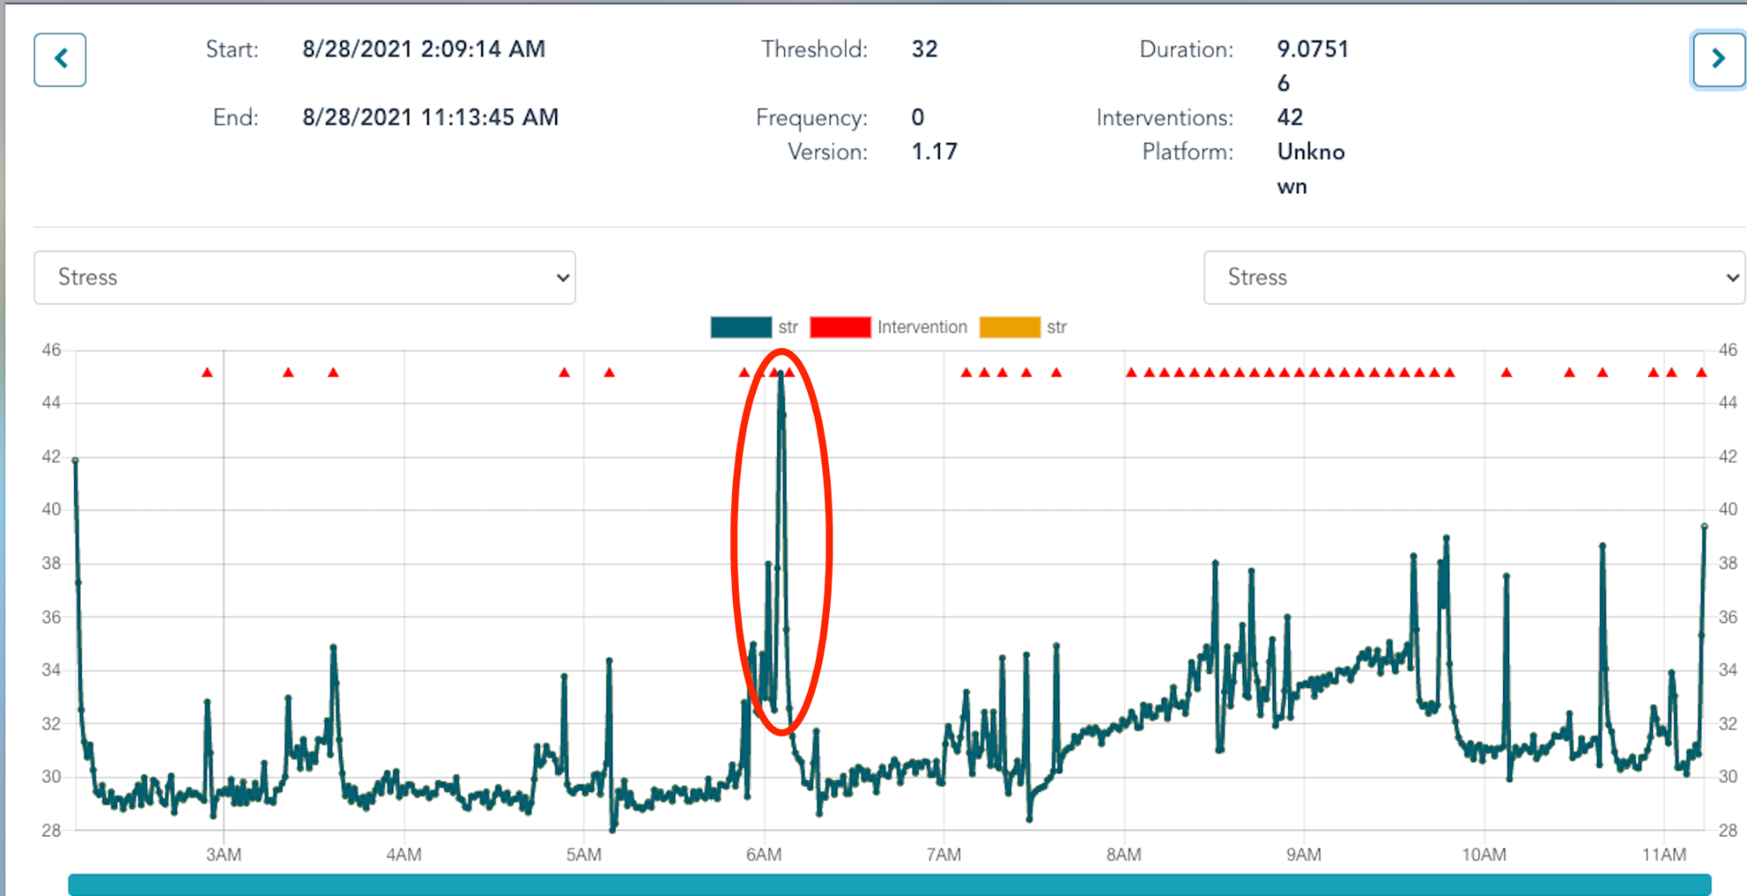

Appendix

Nightmare Disorder Index
A copy of NDI is available at https://jrdietch.com/research/nightmare-disorder-index/.
Licensed copy is free for individual clinical use. The fifth question is about chronicity of nightmare disorder, and will not change with NightWare use. The first four questions may be modified to ask only about the treatment period in question.
Clinicians should use the Continuous Scoring method for assessment.

Pittsburgh Sleep Quality Index Addendum (PSQI-A) for Posttraumatic Stress Disorder
Clinicians can use the form below.
Scoring instructions: Only question 1 components (a to g) are scored. Each component is rated on a 0–3 Severity Scale referring to the frequency of each disturbance (0-Not during the past month; 1-Less than once a week; 2-Once or twice a week; 3-Three or more times a week), and yields a global score with a range of 0–21. Question 2 components are not scored.
- PTSD Checklist, 5th edition (PCL-5)

PSQI-A
INSTRUCTIONS:
Please answer the following additional questions regarding your sleep in the past month. Include any observations from your bedpartner/ roommate.

- During the past month, how often have you had trouble sleeping because you...
- Feel hot flashes:
Not during the past month_____ | Less than once a week_____ | Once or twice a week_____ | Three or more times a week_____
- Feel general nervousness:
Not during the past month_____ | Less than once a week_____ | Once or twice a week_____ | Three or more times a week_____
- Had memories or nightmares of a traumatic experience:
Not during the past month_____ | Less than once a week_____ | Once or twice a week_____ | Three or more times a week_____
- Had severe anxiety or panic, not related to traumatic memories:
Not during the past month_____ | Less than once a week_____ | Once or twice a week_____ | Three or more times a week_____
- Had bad dreams, not related to traumatic memories:
Not during the past month_____ | Less than once a week_____ | Once or twice a week_____ | Three or more times a week_____
- Had episodes of terror or screaming during sleep without fully awakening:
Not during the past month_____ | Less than once a week_____ | Once or twice a week_____ | Three or more times a week_____
- Had episodes of "acting out" your dreams, such as kicking, punching, running, or screaming:
Not during the past month_____ | Less than once a week_____ | Once or twice a week_____ | Three or more times a week_____
2. If you had memories or nightmares of a traumatic experience during sleep (question 1-c above)....
- How much anxiety did you feel during the memories/nightmares?
None_____ | Very little_____ | Moderate_____ | Severe_____
- How much anger did you feel during the memories/nightmares?
None_____ | Very little_____ | Moderate_____ | Severe_____
- What time of night did most memories/nightmares occur?
Early in the night_____ | Middle of the night_____ | Late night, near morning_____ | No particular time_____
Total Score:

A. Germain et al. / Anxiety Disorders 19 (2005) 233–244

End of Document

